Install git and configure repositers in github

1- intalling git in local mahine
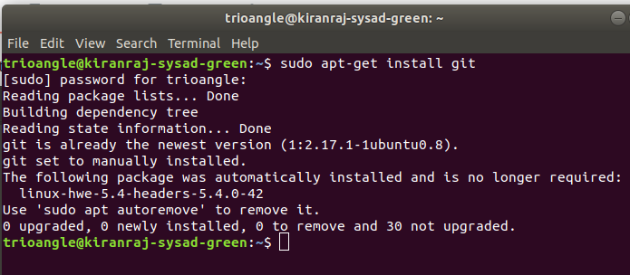

2- open a github webpage and sign in by creating a new account
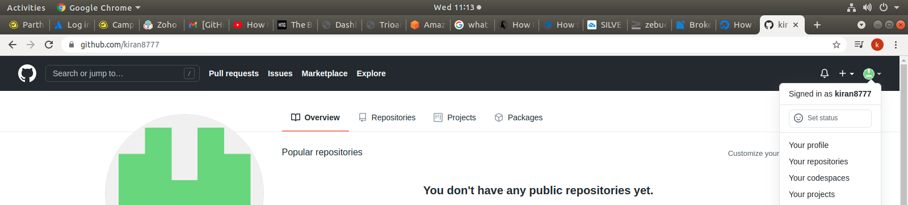
3 - need to set up git username and email ID in ubuntu by providing following command
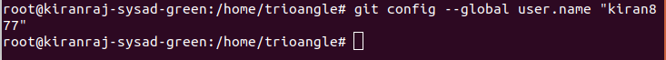
Username -

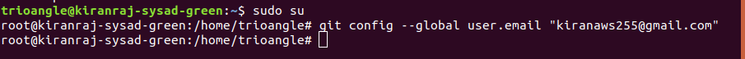
Email -

4 – now got to github and create a new repository
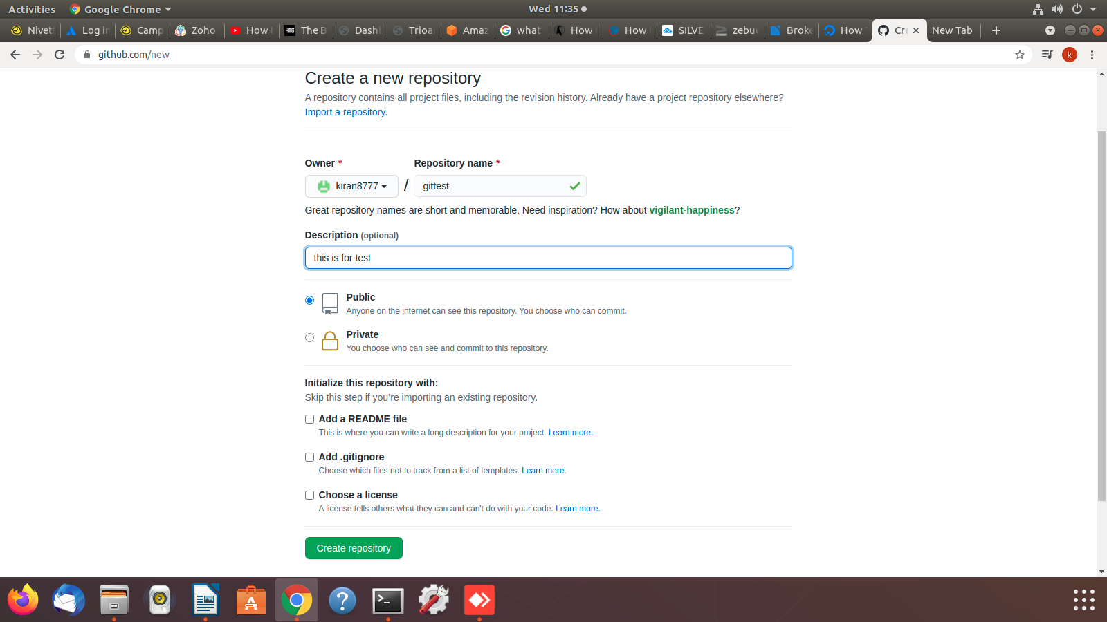

5 – now create a directory in home with the same name created in github
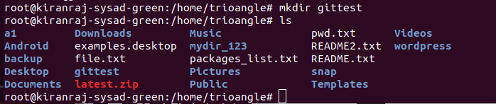

6 – now create a new repository by providing the following command one bye one
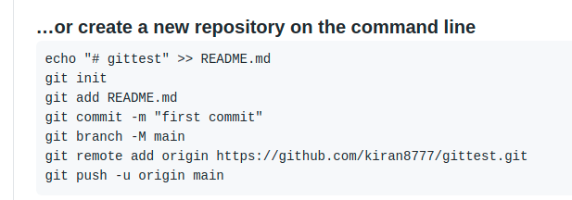
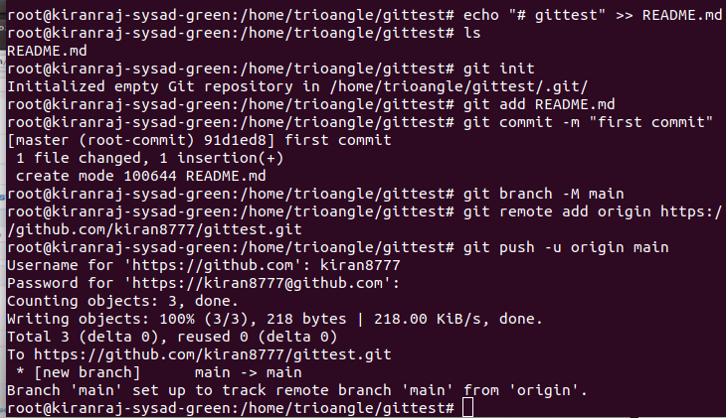

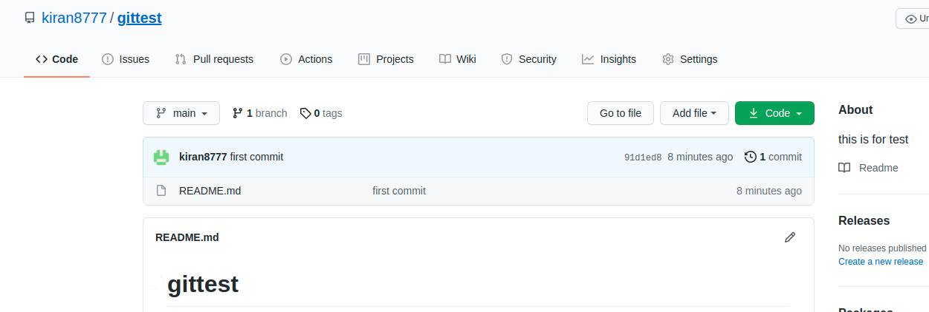

repository has been created

7 - adding a new file by providing following cmd
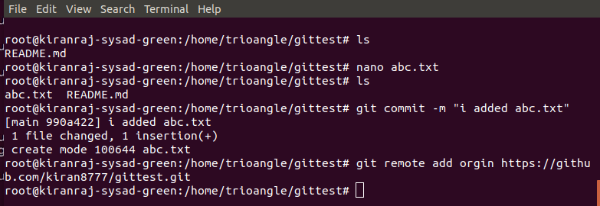

8 - now push the new changes by giving the following command
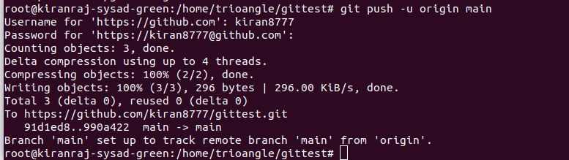

9 – now newly added file has beed pushed to the repository check it by refreshing homefile
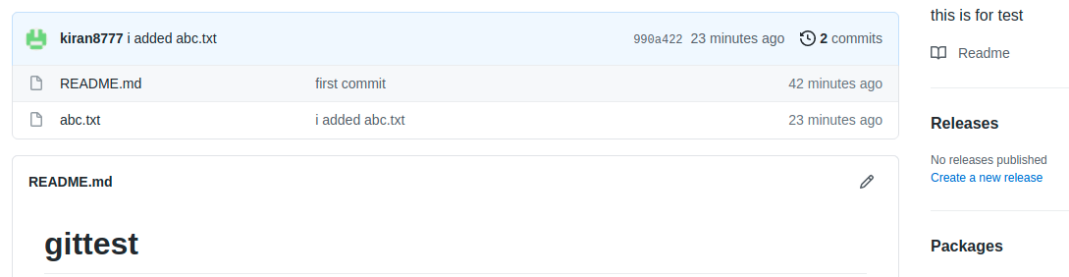

10 click the newly added file and check the content in it


